**Splitting data into training and testing sets for machine learning :**

**(1) import our dataset :**

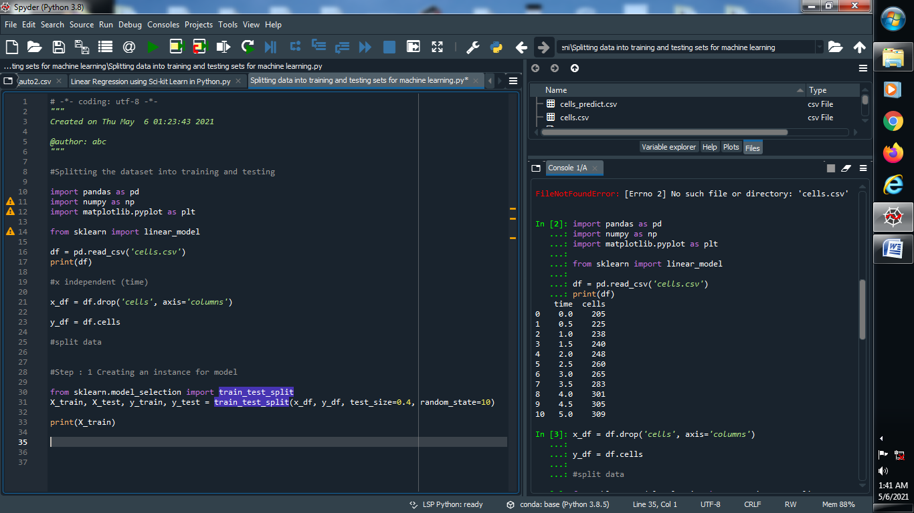

**Output :**



**(2) Creating an instance for our model or our dataset :**

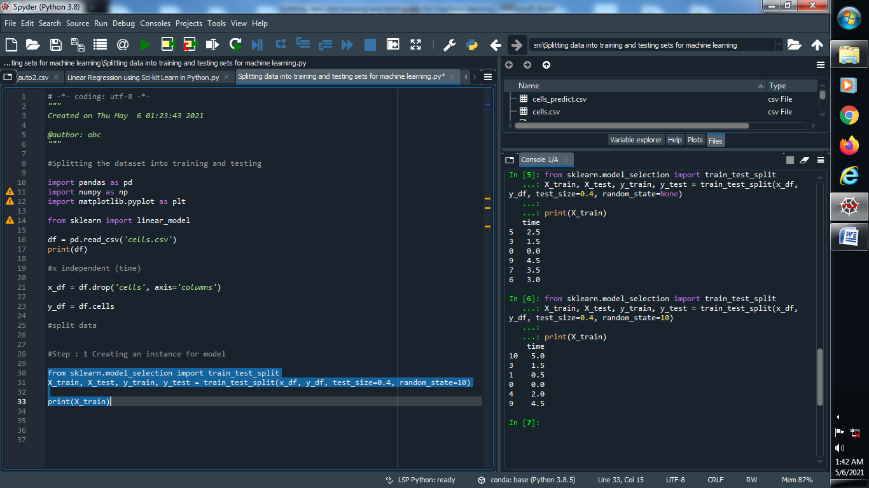

**Output :**



**(3) Fit the dataset :**

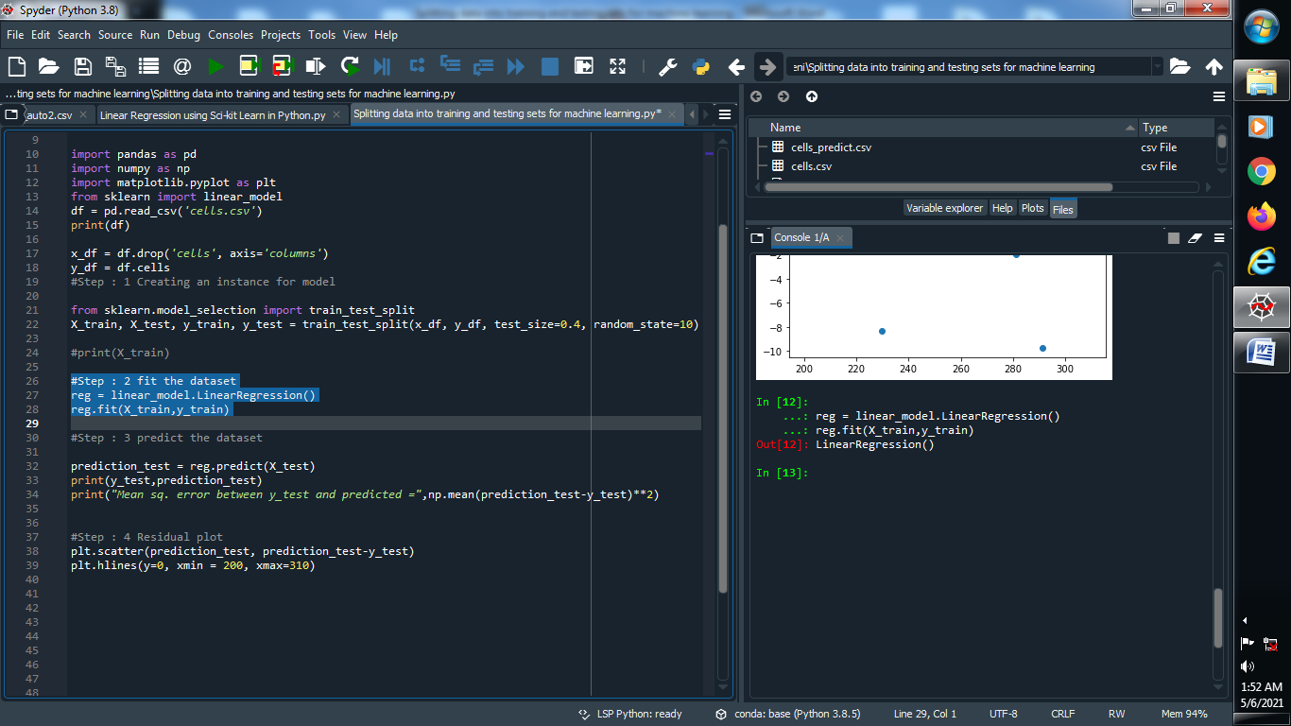

**Output :**



**(4) Predict the dataset :**

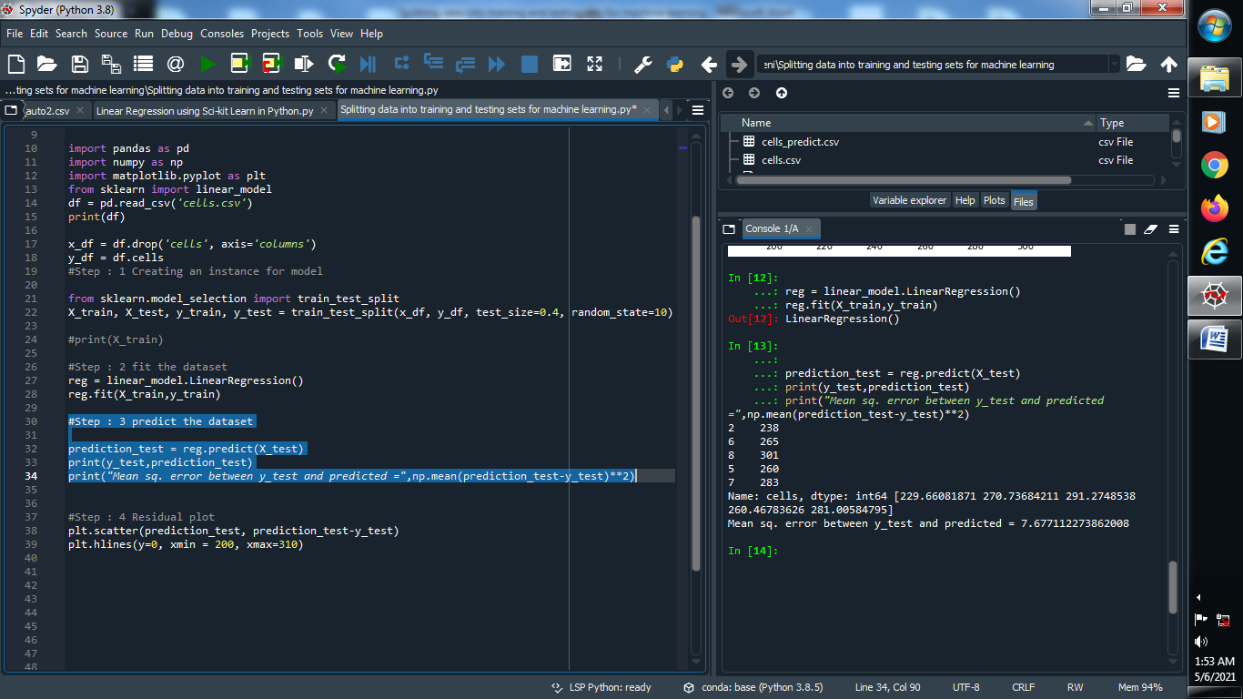

**Output :**



**(5) Put residual plot using scatter :**

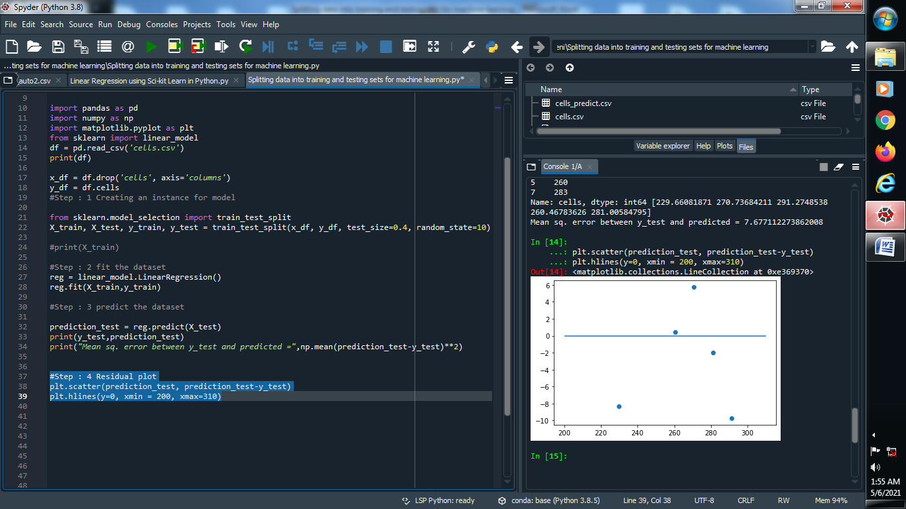

**Output :**

